Centenary
Punchbowl Congregation Church - opened 24th October 1914
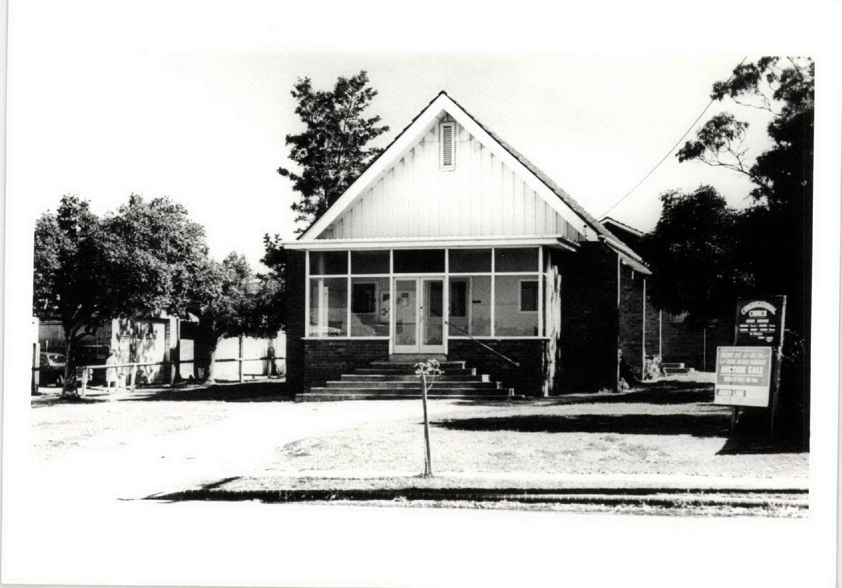

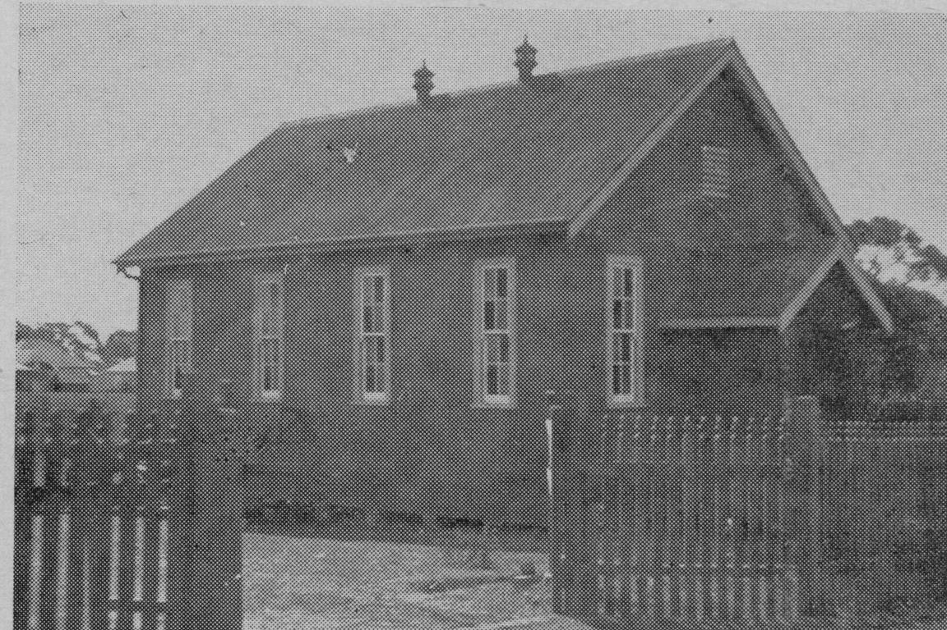

Punchbowl Methodist 1915 – 1st church
Opened 6 February 1915

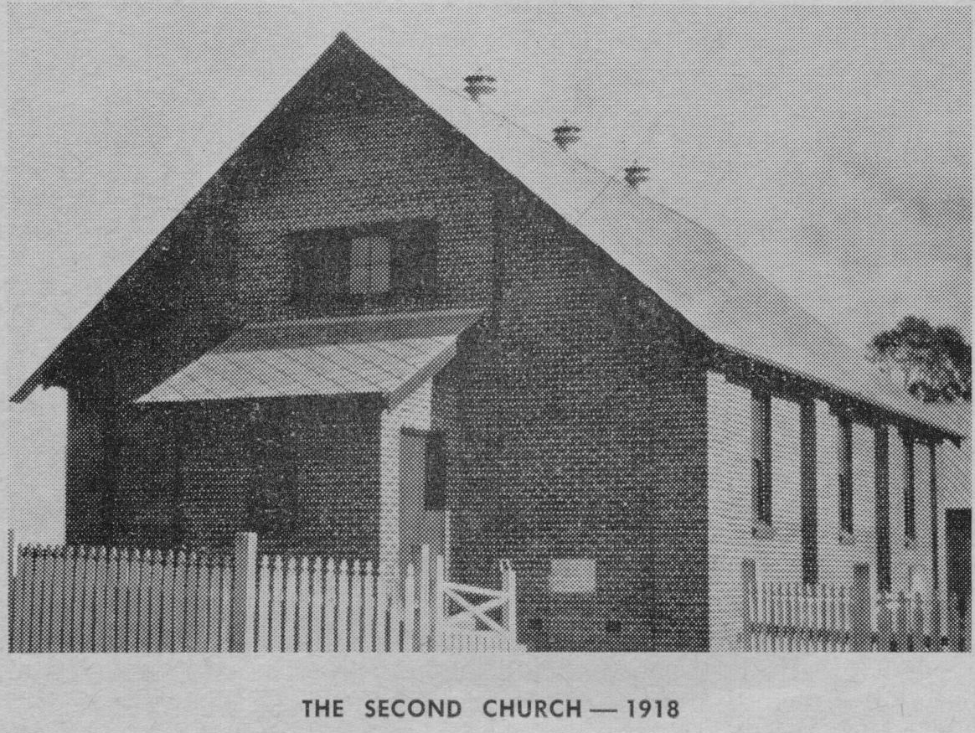

2nd Methodist church opened 21st December 1918

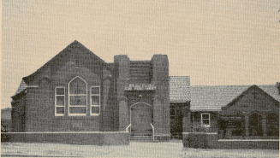

3rd Punchbowl Methodist – opened 19th June 1937

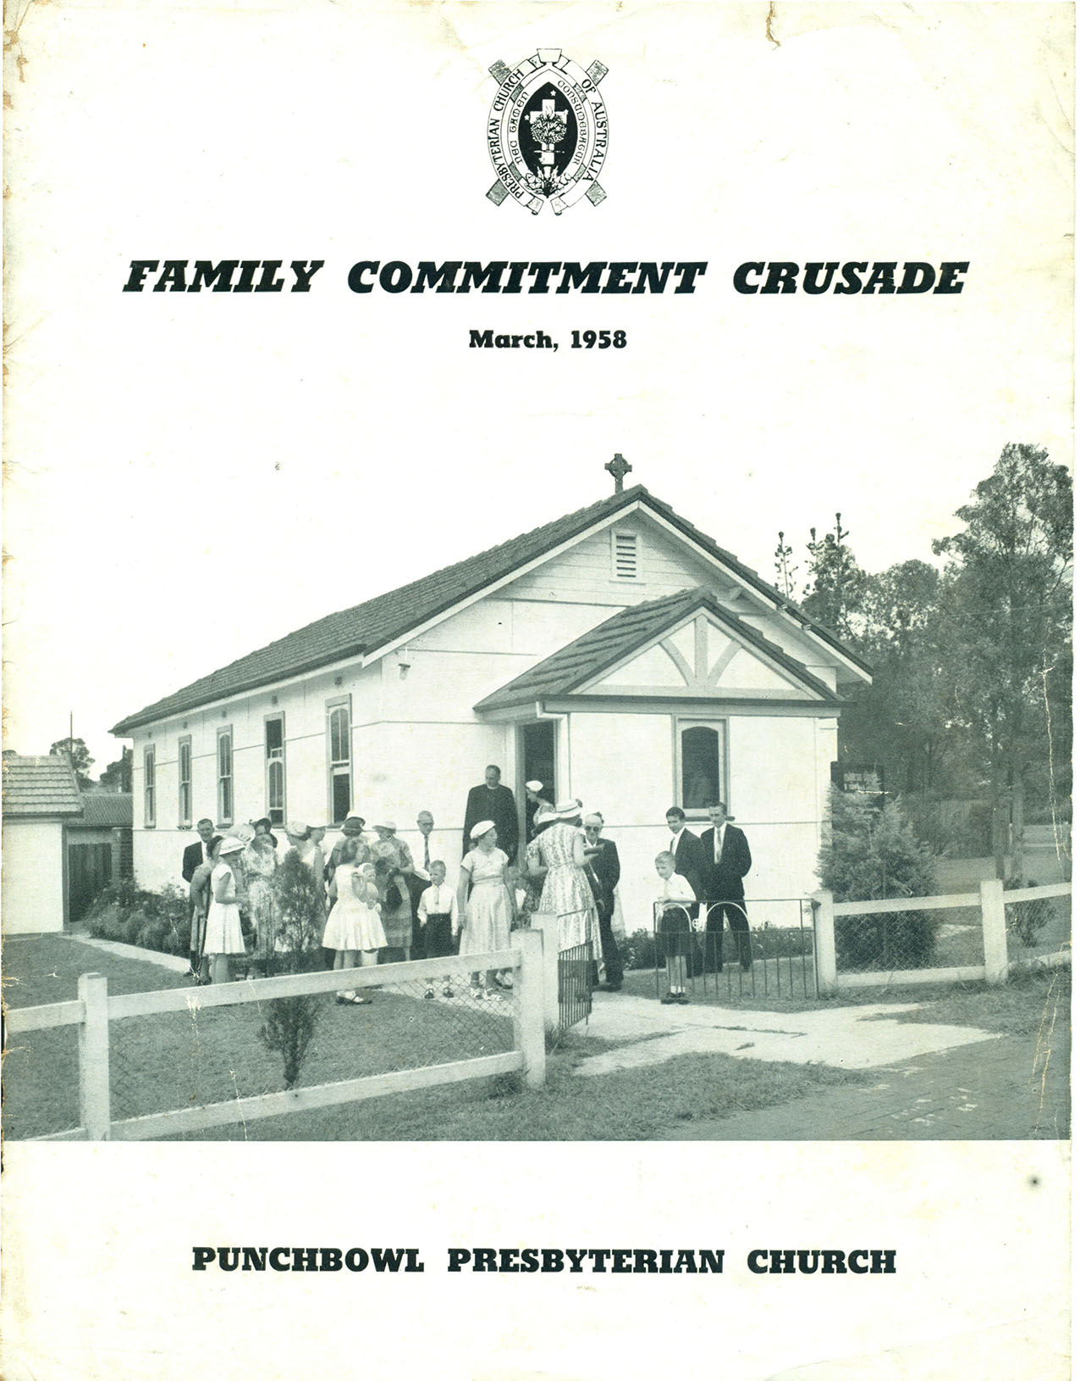

Punchbowl Presbyterian Church opened 12th March, 1949. Photo taken in March 1958

Centenary of Worship at the
Punchbowl Uniting Church on The Broadway
Friday, 6th February 2015.

Celebration

10.30am SATURDAY 7th FEBRUARY 2015
Centenary Service
We will be worshiping in the church,
followed by a light lunch in the hall ($10)

For further details
PO Box 209 Punchbowl NSW 2196
Email: punchbowluc100@gmail.com

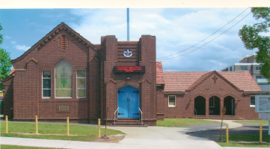

Punchbowl Uniting Church 2014

